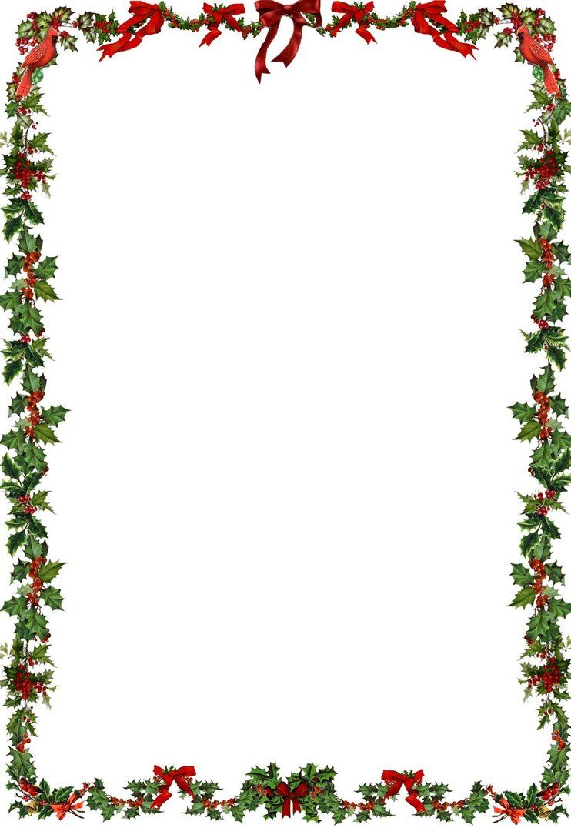
The Strickland Arms December opening times
(Being in tier 2 we can only serve tables form one household or social bubble. Also, everyone must order a substantial meal. We can not allow customers in just for drinks. Thank you.)
Tuesday 1st CLOSED
Wednesday 2nd CLOSED
Thursday 3rd OPEN
Friday 4th OPEN
Saturday 5th OPEN
Sunday 6th OPEN
Monday 7th CLOSED
Tuesday 8th CLOSED
Wednesday 9th OPEN
Thursday 10th OPEN
Friday 11th OPEN
Saturday 12th OPEN
Sunday 13th OPEN
Monday 14th CLOSED
Tuesday 15th CLOSED
Wednesday 16th OPEN
Thursday 17th OPEN
Friday 18th OPEN
Saturday 19th OPEN
Sunday 20th OPEN
Monday 21st CLOSED
Tuesday 22nd CLOSED
Wednesday 23rd OPEN
Thursday 24th (Christmas eve) OPEN
Friday 25th (Christmas day) CLOSED
Saturday 26th (boxing day) OPEN
Sunday 27th OPEN
Monday 28th OPEN
Tuesday 29th OPEN
Wednesday 30th OPEN
Thursday 31st (New Year’s Eve) OPEN

