Christmas menu 2019

Starters

Celeriac and chestnut soup served with a baker’s bread roll and butter.

Smoked mackerel pate with pickled cucumber, raw fennel, pea shoots and toasted sourdough bread.

Roasted pork belly with pear, garlic purée, crispy sage leaves and a port jus.

Cheese fondue served with sourdough bread, carrot and cucumber sticks.

Mains

Butter basted turkey breast, with roast root vegetables, duck fat roast potatoes, Brussel sprouts with bacon and chestnuts, pigs in blankets and a turkey gravy.

Pan fried rainbow trout served with celeriac and pancetta rosti, lime butter sauce and pea shoots.

Butternut squash, goat’s cheese and thyme filo tart served with a warm fig and walnut salad.

Slow braised beef cheek with creamed mash, tender stem broccoli, pancetta crisp and a red wine gravy.

Desserts

Christmas pudding served with brandy sauce and red currants.

Lemon posset served with rosemary short bread, raspberries and lemon balm.

Gingerbread cake served with a caramel sauce, vanilla pod ice cream and micro coriander.

2 courses @ 21.95
3 courses @ 25.95

Coffee and Mince pie £4.25

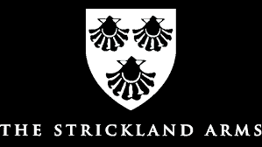

Telephone 015395 61010 or email thestricklandarms@yahoo.co.uk

